Introduction to Array Variables
By Mr. William L. Bahn

Outline

- Example problem – calculating aircraft weight and balance.
- Motivation for arrays – sometimes simple variables aren’t so simple to use.
- What are array variables and what is array notation?
- How do use array variables?
- How do we create array variables in Raptor?
- What are parallel arrays?
- Summary
- Glossary

Example problem – calculating aircraft weight and balance.

Let’s consider a real-world problem - determining the center-of-gravity for an aircraft. The following algorithm is the normal procedure used by countless pilots every day:

- For each item that makes up the aircraft:
  - Take that item’s weight and multiply it by that item’s moment arm to obtain that item’s moment.
  - Add that item’s moment to the total moment for the aircraft.
  - Add that item’s weight to the total gross weight for the aircraft.
- Obtain the aircraft’s center of gravity by dividing its total moment by its total gross weight.

First, a bit of explanation regarding the terms used in the above algorithm:

- An “item” is any object that is part of the overall aircraft. It includes the fuel, the cargo, the crew and passengers, the empty aircraft itself, and anything else. Every object must be taken into account exactly once. Each item has two numbers associated with it – its weight and its moment arm.
- An item’s “weight” is simply how much the object weighs. We will use pounds for everything we do.
- An item’s “moment arm” simply tells us where the item is located within the aircraft. Just like a football’s position on a football field is usually indicated by how many yards it is away from a particular team’s goal line, the location of an item in an aircraft is indicated by how many inches it is aft (behind, or toward the rear of the aircraft) of the “datum”, which, like the goal line, is simply an agreed upon reference point for that particular aircraft. On most light, single-engine aircraft the datum is the firewall on which the engine is mounted. Hence items located behind the firewall (which is the vast majority of them) will have positive moment arms while objects located in front of the firewall will have negative moment arms.

Let’s work a simple toy example where we only have three items – the empty aircraft, the fuel, and a pilot.

Item #1: 1500 lb located at 34.3 inches.
Item #2: 125 lb located at 29.7 inches.
Item #2: 185 lb located at 37.2 inches.

Following is a manual computation of this aircraft’s center of gravity:

Item #1: 1500 lb * 34.3 in = 51450.0 in-lb
Total moment: 51450.0 in-lb
Gross weight: 1500 lb
Item #2: 125 lb * 29.7 in = 3712.5 in-lb
Total moment: 51450.0 in-lb + 3712.5 in-lb = 55162.5 in-lb
Gross weight: 1500 lb + 125 lb = 1625 lb.
Item #3: 185 lb * 37.2 in = 6882.0 in-lb
Total moment: 55162.5 in-lb + 6882.0 in-lb = 62044.5 in-lb
Gross weight: 1625 lb + 185 lb = 1810 lb

Center of gravity: 62044.5 in-lb / 1810 lb = 34.3 inches (aft of the datum).

Motivation for arrays – sometimes simple variables aren’t so simple to use.

As we’ve already seen, a ‘variable’ in a computer program is a location where we can store a single piece of information. The fact that we can later retrieve and/or change that information is at the core of what computers and computer programs are and why they are useful to us.

To make our life simpler and reduce the chance of making arithmetic mistakes, let’s implement this "center-of-gravity for an aircraft" algorithm using Raptor. We’ll initially assume that our aircraft consists of three items, just like our toy problem. We want our program to ask us for the information for each of the three items and to then report the final gross weight and center-of-gravity. The Raptor program in Figure 1 does this using only the types of variables that we have discussed up to this point.

This program works, but it has major shortcomings. The most significant is that if we want to work with more than three items, we must rewrite the program. Second, consider the number of symbols in this flowchart. This is a fairly large program given the very simple nature of the algorithm being implemented. Finally, consider how completely unmanageable this program would be if we wanted it to work for an aircraft with hundreds of items (such as a large cargo or passenger aircraft), especially since we really don’t know how many items we need to handle at the time the program is written.

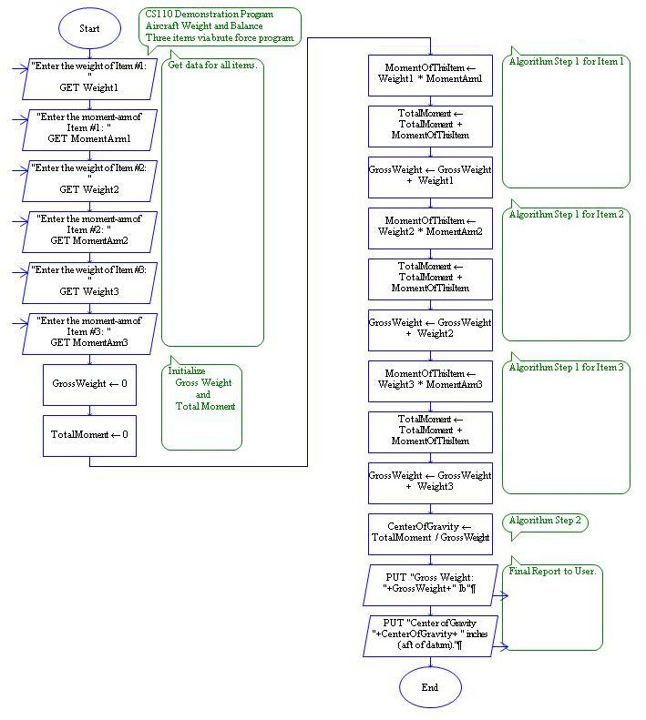
Figure 1 - Brute force Raptor program to perform weight and balance calculations.

Let’s examine this program a little closer and see what new features we would like to add to Raptor in order to overcome these shortcomings. Consider the initial portion of the program where we are getting data for all of the items. This consists of a total of six symbols, but notice that the first pair of symbols are only slightly different from the second pair and the third pair. In fact, using what we already know about iterations, we could almost accomplish our desired goal for this portion of the program using the flowchart fragment shown in Figure 2.

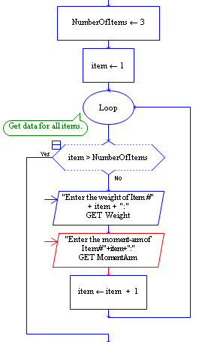
Figure 2 - First attempt at a loop to get data.

Notice that this fragment will not only ask the user for three weights and three moment arms, but it will even issue the same prompts as the original program, including the item numbers. The only problem with this loop – and it’s a big one – is that we are only using two variables, Weight and MomentArm, when we need to have a total of six variables (to hold the six different values that the user is going to enter). With this loop, we will overwrite the previously entered values each time the loop executes and, as a result, when the loop is finished we will only have retained the weight and moment arm for the very last item entered.

What we need is a way to tell Raptor that we want to work with different variables on each pass through the loop. More specifically, we need a mechanism so that the same symbol doesn’t have to use the same variables each time it is executed. With the types of variables we have used up to this point, commonly called “simple variables”, that is not possible. Array variables, however, make it possible - and simple.

What are array variables and what is array notation?

Consider the following three simple variables:

Weight1
Weight2
Weight3

As far as Raptor is concerned, these are three completely different variables – they could be called Fred, Bob, and Sue for all Raptor cares – and each is capable of holding a single value. Whenever we want to work with that value, we must explicitly refer to that variable by name.

Now let’s expand the naming convention we have used up to this point to permit us to slightly rename these variables as follows:

Weight[1]
Weight[2]
Weight[3]

The change we have made to our naming convention is the following: A variable name may end with a number (integer greater than zero) enclosed in square brackets. Each such variable remains unique and distinct – just as Weight1 and Weight2 are different variables and hold different values, so too are Weight[1] and Weight[2]. The number in brackets is called the “index” of that particular variable.

This manner of naming variables is typically referred to as “array notation”. In the above example, we might say that we have an array called “Weight” that has a dimension of three. This simply means that we are using array notation to create three unique variables all of which share the same root name of “Weight”. Another term that is commonly used with arrays is “element”. Our array consists of three elements and the value of the index tells us which of those elements is being referred to at any given point.

Up to this point the addition of array notion really hasn’t changed anything – at least on the surface. To show that this is the case, we could take the brute force program and change the name of the variable Weight1 to Weight[1] (just as any time we rename a variable, we must be careful to make the change everywhere that variable is used) while leaving Weight2 and Weight3 alone. Similarly, we could change MomentArm2 to MomentArm[2] every place. The program will still work just fine.

There is one subtle distinction that should be pointed out and now is as good a place as any to do so. If we use simple variables named Weight1 and Weight2, then there is nothing to prevent us from using another variable named just Weight and it would be yet one more completely unrelated variable with its own unique name. But when we use array notation we lose that ability. If we have a variable named Fred[52] (or any other index), then we can’t use Fred by itself as a variable name. However, this is a minor price to pay for the extreme benefits we are about to gain.

How do we use array variables?

The benefits of array variables derive from the fact that array notation permits Raptor to perform math on the portion of the name that is within the square brackets. In other words, Raptor can calculate the value of the index. As a result, all of the following refer to the same variable because the expressions all evaluate to the same index value:

Weight[2]
Weight[1 + 1]
Weight[23 – 21]
Weight[(5 – 14)*2 + 4*7 – 2*(7 – 3)]

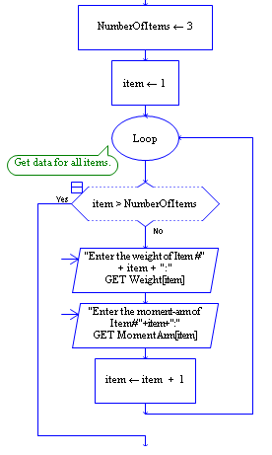
If this was the limit of what we could now do, it would be of limited utility. However, the expression within the square brackets can be ANY legal expression that yields a positive integer – including expressions that involve other variables – and Raptor recalculates the value of the index every time it executes a symbol containing an array variable. Therein lies the extreme power of array variables and array notation.

Consider the slightly modified code fragment shown in Figure 3. The only change we have made is to use arrays for Weight and MomentArm – but what a profound change that turns out to be. Because we use an expression – in this case consisting of just the variable “item” – for the index and because the value of "item" changes each time through the loop, we have achieved our goal of not having to always refer to the same variable each time a particular symbol is executed.

Figure 3 - Raptor code using arrays to store data

The Raptor program shown in Figure 4 performs exactly the same as the original version in Figure 1. At first glance the two programs appear pretty comparable in terms of total number of symbols and the array-based program looks more complex because of the presence of the loops. Both of these observations are quite true, but consider the situation from a slightly different perspective. Which program would you rather modify if asked to create a program that worked for an aircraft consisting of four items? In the first program you would have to add five new symbols. In the second, you would only have to change the first symbol after the Start bubble so that the value that is stored in the variable “NumberOfItems” is 4 instead of 3. To really drive the point home, consider modifying the first program so that it can handle one hundred items!

At this point we have addressed several of the shortcomings of the original program – at least now we can trivially change the program to handle different numbers of items. But we still have to modify the program each time we want to do so. Modifying the original program so that you could handle an unknown (to the programmer) number of items would be impossible. But making such a modification to the second program is simple – merely change the symbol where the variable “NumberOfItems” gets set from an assignment symbol to an input symbol and ask the user how many items make up this aircraft.

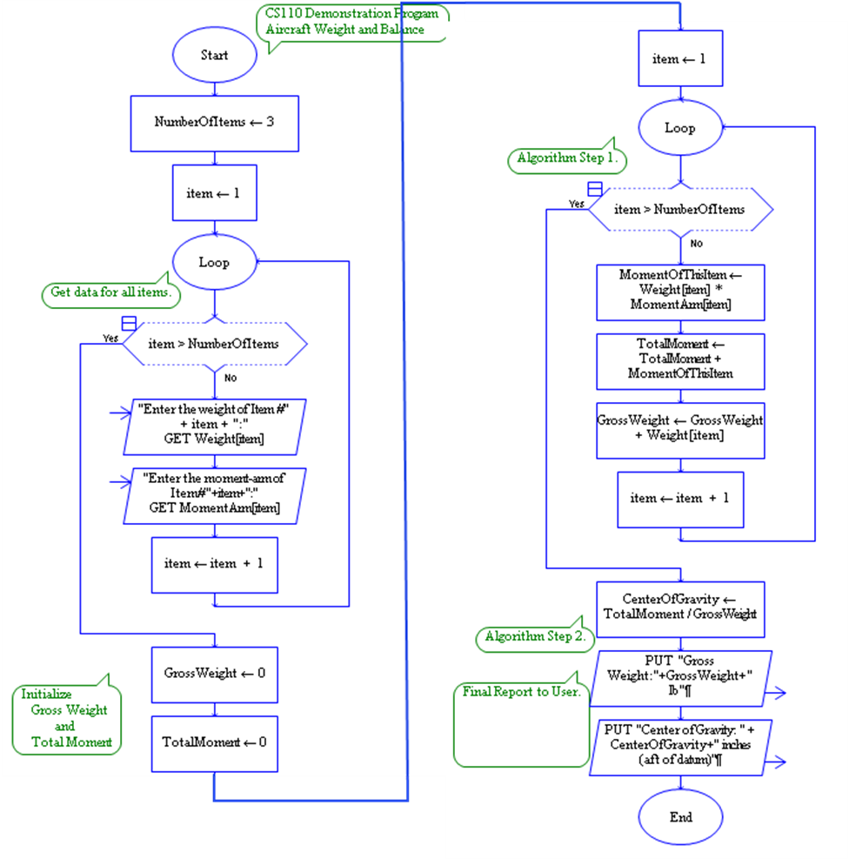
Figure 4 - Weight and balance program using arrays.

How do we create array variables in Raptor?
Our discussion on this topic can be very brief because we already know how to create array variables in Raptor. Just like ordinary simple variables in Raptor, a variable that is part of an array is automatically created by Raptor the first time it is used to store a value. For example, in the first loop in the program above, say a value has just been stored in Weight[2], that variable now exists and can be used in expressions from that point on.

However, Raptor also does something else for us that can be useful. If we store a value in, say, Fred[100], then Raptor will automatically create any variables Fred[1] through Fred[99] that have not already been created and store zeros in them. If, for instance, Fred[13] had already been created and had a value stored there, it’s value would not be changed.

What are parallel arrays?

Let’s examine a feature of our new program that we’ve used without commenting on up to this point. If asked what the weight and moment arm of item #2 are we would get the values stored in the variables Weight[2] and MomentArm[2]. Rather obvious, right?

However, “Weight” and “MomentArm” are two different arrays that don’t have to have anything to do with each other – Raptor certainly doesn’t care whether they do or not. But we have chosen to use them in such a way that the information contained in one is related to the information contained in the other in a very simple and useful way. Specifically, the data for the same item is stored at the same index in the respective arrays. Arrays used this way are called “parallel arrays”. Hopefully it is apparent that parallel arrays are neither particularly special nor difficult to understand or use – we essentially invented them as a consequence of doing what seemed most natural while solving the problem.

Summary

There are many situations in programming when we need to work with a large number of related data values and using simple variables would be cumbersome or impractical. Arrays allow us to use a single base name, combined with an index value, to refer to many different individual variables. Because the index value is computed from an expression each time a reference to an array variable is encountered, arrays are ideally suited to situations where we want to loop through a large number of variables, working with a different one on each pass.

Glossary

Array element – A specific variable that is part of an array variable. The specific value being referenced is determined by the value of the array index.

Array index – The value that determines the specific element of an array variable being referenced. The index can be any mathematical expression that evaluates to a single positive integer. The index is always contained within square brackets appended to the array variable’s base name.

Array notation – the means used to refer to an array element consisting of the array’s base name immediately followed by the element’s index expression enclosed within square brackets.

Array variable – A collection of variables, each of which can be used to store and retrieve a single value, that share a common base name and are distinguished from each other by means of a unique index value.

Base name – The common name shared by all of the individual variables that make up a particular array variable.

Simple variable – A variable without an array index that can be used to store and retrieve a single value.

